# Health, Harms, Deaths and Illnesses

**Introduction**

Air pollution has a vast effect on a number of illnesses. In particular air pollution affects sufferers of asthma and Chronic Obstructive Pulmonary Disease (COPD). In addition to this, other illnesses and health defects can be caused by long term exposure to pollution, such as lung diseases. In particular, long term exposure to pollution for young children can lead to heavy impacts upon the health of the child on both a short and long term basis, some developing health defects which last a lifetime.

**Asthma**

Asthma is a long term illness which can cause coughing, wheezing, chest tightness and breathlessness. These symptoms can vary from person to person, however most sufferers will suffer more severe symptoms when air pollution levels are high.

The cause of asthma is the inflammation of the small tubes, called bronchi, within the lungs. When coming into contact with something which inflames the bronchi, known as a trigger, the airways become narrow and cause an ‘asthma attack’[1] Asthma attacks can be dangerous, in the USA there are over 3000 deaths directly caused by an asthma attack every year.[2]

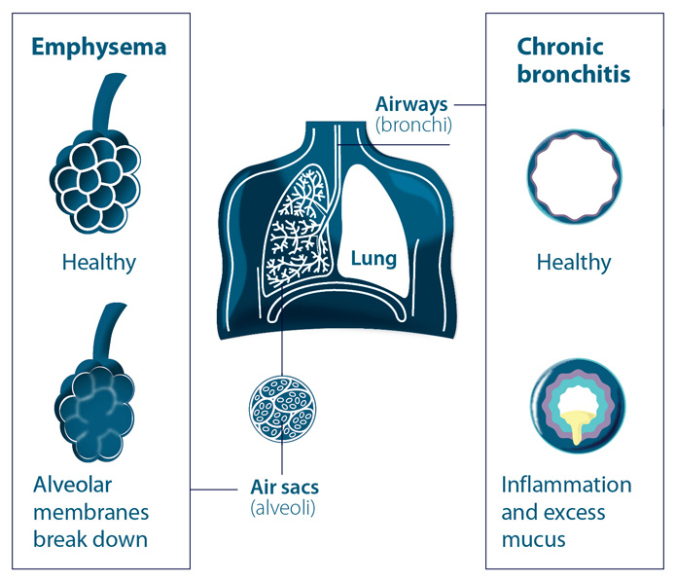

**COPD**

Chronic Obstructive Pulmonary Disease is actually a name for a collection of diseases such as chronic bronchitis and emphysema, however all these diseases have similar effects and similar causes. COPD is a condition where the airways become inflamed and the air sacs in the lungs become damaged (see image, right[3]).

People with COPD suffer breathing difficulties, particularly when external conditions are poor, for example when air pollution is high. There is no cure for COPD, however there are many treatments which help the sufferer to manage the symptoms.

**Effects of air pollution on asthma and COPD**

The key issue with air pollution is that the pollution acts as a trigger to the diseases. For asthma the problem depends on the type of pollutant. For example particulate matter can become lodged within the lungs of the sufferer and cause an attack. Nitrogen Dioxide can react with other pollutants in the air to form small particles which can lead to breathing difficulties. Exposure to gaseous pollutants at an early age increases the risk of developing asthma.[4]

Asthma UK did a study which found that on days where there were high levels of pollution, asthma sufferers reported a third of respondents had an asthma attack and 86% used their blue reliever more than usual.[5]

There is a large amount of evidence to support the fact that increased exposure to air pollution can be a risk factor in developing COPD. Additionally high levels of air pollution can also exacerbate the symptoms of COPD.[6] In the same way, long term exposure to smaller levels of air pollution can also lead to the progression of COPD.[7]

**Other health risks from air pollution**

Some of the major risks to health other than asthma and COPD are the increased chance of developing lung cancer, suffering a stroke and also heart and respiratory diseases. Ambient air pollution levels are attributed to being the cause of premature death of 3.7 million people worldwide in 2012.[8] Although some of the conditions listed above may have had other causes than air pollution, for example lung cancer could have been caused by smoking or other factors, however in some cases cancer may have been prevented by reduction in air pollution.

1. <http://www.nhs.uk/conditions/asthma/Pages/Introduction.aspx>
2. <http://www.nrdc.org/health/effects/fasthma.asp>
3. <https://www.blf.org.uk/Page/what-is-COPD>
4. <http://www.nrdc.org/health/effects/fasthma.asp>
5. <http://www.asthma.org.uk/knowledge-bank-pollutants?utm_source=umbraco&utm_medium=redirect&utm_campaign=umbraco>
6. <http://copd.about.com/od/copdbasics/a/The-Effects-Of-Pollution-On-Copd.htm>
7. <https://copd.net/basics/causes-risk-factors/who-is-at-risk/air-pollution/>
8. <http://www.who.int/mediacentre/factsheets/fs313/en/>